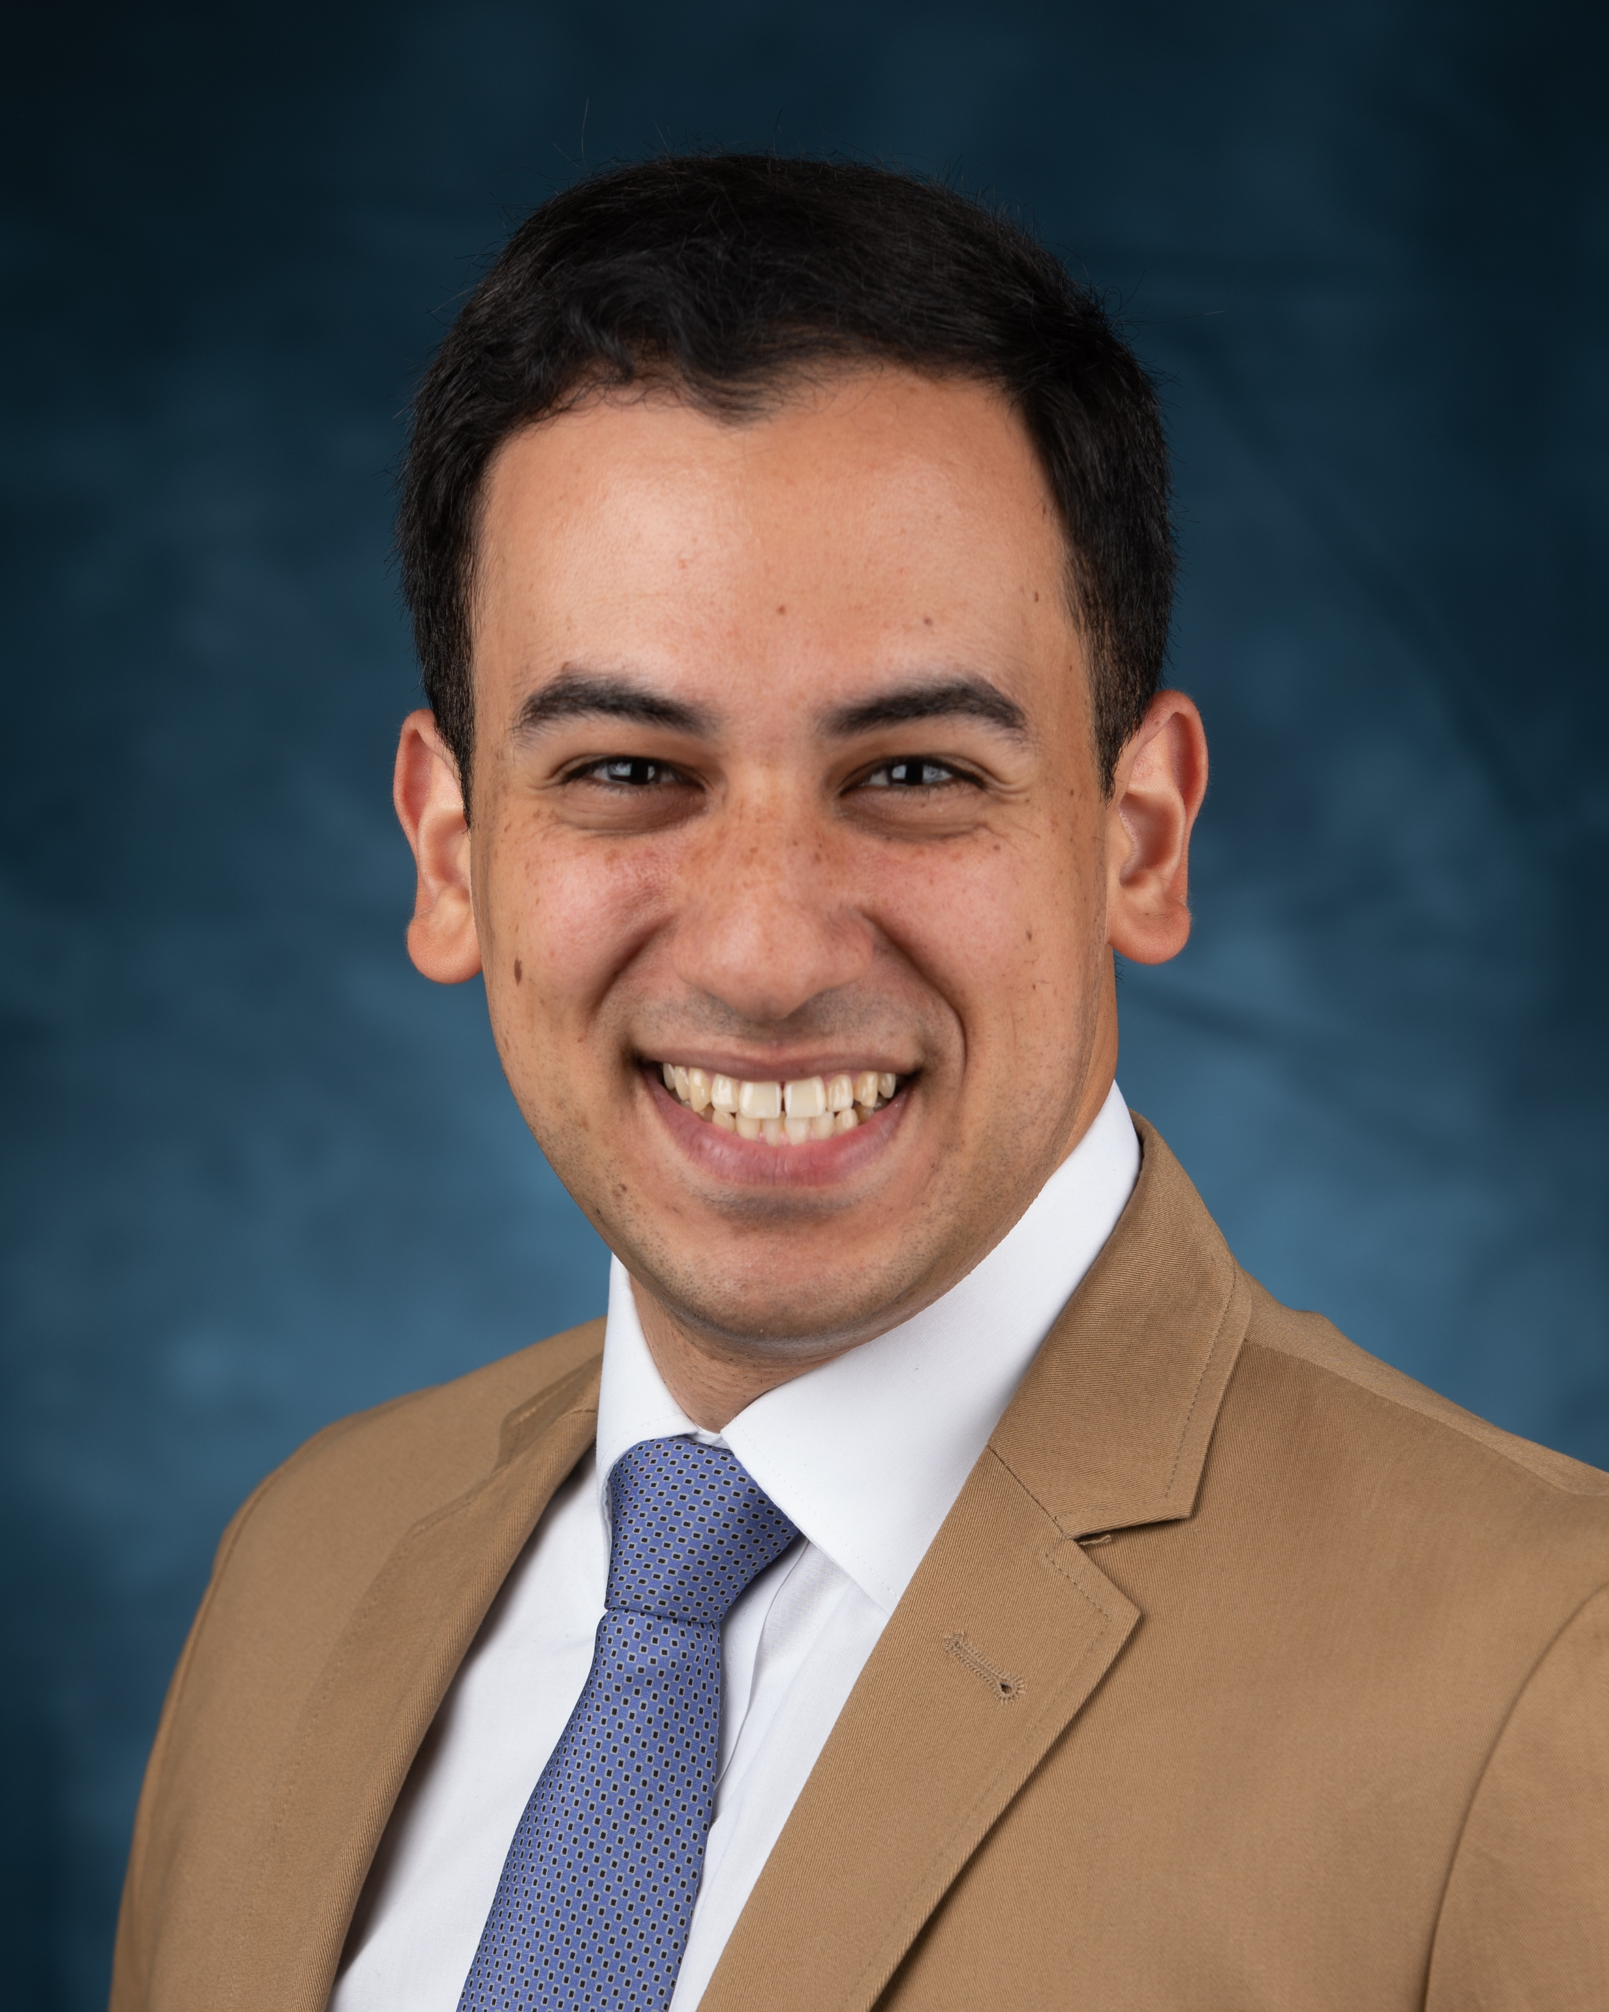

Andrew Abadeer
M.D., M. Eng.
Education
OrthoCarolina Hand Fellowship, Charlotte NC 8/1/2024-7/31/2025
Medstar Georgetown University Hospital, Washington DC 6/18/2018-6/22/2024
Resident Physician in Plastic and Reconstructive Surgery
Columbia University College of Physicians and Surgeons, NY NY 5/20/2013-5/16/2018
M.D., May 2018
Stevens Institute of Technology, Hoboken NJ 6/1/2009-5/23/2013
M. Eng. | Master of Engineering* with Thesis in Biomedical Engineering, May 2013
B.E. | Bachelor of Engineering* in Biomedical Engineering, May 2013
Experience
Academic Chief Resident, Medstar Plastic Surgery 2023-2024
Physician Leadership Council, Medstar Health 2021-2023
Weill Cornell Medical College, NY NY 2016-2017
Visiting Research Fellow & Glorney-Raisbeck Grant Recipient
Stevens Institute of Technology, Hoboken NJ 2009-2013
Research Fellow
EEG Detection of Motive Intent (Thesis) 2012-2013
Cardioresponsive Control of Left Ventricular Assist Devices (LVAD) 2012-2013
Haptic Feedback for Integrative Robotic Surgery 2011-2013
Academia
Grants/Awards
2025-Resident Teacher Award, Program Wide
2025-Greenbrier Research Award, Program Wide
2024-Research Award, Program-Wide
2024-Grant, Axogen Education: Microsurgical Cadaver Lab
2022-Clinical Performance Award, Program-Wide
2022-Mother of Pearls, Award, Highest Excellence in Medical Student Teaching, System-Wide
2022-Top Abstract, PSTM, “Illuminating the Proximal Phalanx: New Insights Based on Micro-Computed Tomography”
2021-String of Pearls, Award, Excellence in Medical Student Teaching, System-Wide
2021-Achievement in Research Award, Program-Wide
2021-Grant: “Intraosseous Perfusion of the Proximal Phalanx”. Raymond M. Curtis Grant
2020-String of Pearls, Nominee, System-Wide
2019-String of Pearls, Award, System-Wide
2017-Grant: "Plug ’N Play: Perfusable Capillary Networks”. Combined PSF/ASRM Grant
2017-Grant: “Collagen Microsphere Scaffolds (MSS)”. Glorney-Raisbeck, New York Academy of Medicine.
2014-Grant: "Acute Kidney Injury in Patients on Mechanical Circulatory Support” NIH-T35.
Selected Publications:
Abadeer AI, Hembd A, Brooks D, Higgins JP, Giladi AM, Shubinets V. Arterial Perfusion of the Medial Femoral Trochlea Flap Examined by Micro-Computed Tomography Angiography. J Hand Surg Am. 2025 Aug;50(8):915-921. doi: 10.1016/j.jhsa.2025.04.008. Epub 2025 May 23. PMID: 40407763. Editors Choice | Front Cover Image | CME
Abadeer AI, Wu CM, Brooks DM, Higgins JP, Giladi AM, Shubinets V. Arterial Perfusion of the Proximal Phalanx Revisited: New Insights Based on Micro-Computed Tomography. The Journal of Hand Surgery. Online Ahead of Print. 2022.
Abadeer AI, Scollan JP, Loeffler, BJ. Partial Hand Amputations. Reconstruction of Upper Limb Amputations. Book Chapter. In Print.
Abadeer AI, Hembd A, Brooks D, Cuningham B, Higgins JP, Giladi AM, Shubinets V. Arterial Perfusion of the Medial Femoral Trochlea Flap: Elucidation of Perfusion by Micro-Computed Tomographic Angiography. Annual Meeting of the ASRM. Nassau, Bahamas. 2024. [accepted]
Abadeer AI, Parikh R, Rebehn K, O’Malley K, Kleiber G. Pulling the Trigger: Redefining Early Exploration for Ballistic Nerve Injury. 2023 Annual Meeting of ASPN. Nassau, Bahamas. 2023. [accepted]
Abadeer AI, Gary C, Brooks D, Higgins JP, Giladi AM, Shubinets V. The Proof is in the Periosteum: Redefining Metacarpal Perfusion by Micro-Computed Tomography Angiography 2023 Annual Meeting of the AAHS. Miami, Florida. 2023. [accepted]
Abadeer AI, Wu C, Brooks D, Higgins JP, Giladi AM, Shubinets V. Illuminating the Proximal Phalanx: New Insights Based on Micro-Computed Tomography. Plastic Surgery the Meeting. Boston, Massachusetts. 2022.
Abadeer AI. Functional Limb Salvage: Practical Lessons Learned in Managing Diabetic Foot Infections. Springer, 2023. Textbook Chapter.
Abadeer, AI, Kurlansky, P., et al. Importance of stratifying acute kidney injury in cardiogenic shock resuscitated with mechanical circulatory support therapy. The Journal of thoracic and cardiovascular surgery, 154(3), pp.856-864. In Print. 2017.
Karinja, S.J., Bernstein, J.L., Mukherjee, S., Jin, J., Lin, A., Abadeer, AI, Kaymakcalan, O., Veiseh, O. and Spector, J.A., 2023. An Antifibrotic Breast Implant Surface Coating Significantly Reduces Periprosthetic Capsule Formation. Plastic and Reconstructive Surgery, 152(4), pp.775-785.
Kirloskar, K. M., Haffner, Z. K., Abadeer, AI, Yosaitis, J., Baker, S. B., & Innovations, M. I. (2023). The Innovation Press: A Primer on the Anatomy of Digital Design in Plastic Surgery. Annals of Plastic Surgery, 91(2), 307-312.
Spoer, D. L., Junn, A., Bovill, J. D., Haffner, Z. K., Abadeer, AI., & Baker, S. B. (2023). Evolving the Cybersecurity of Clinical Photography in Plastic Surgery. Archives of Plastic Surgery, 50(04), 443-444.
Gary, C. S., Kirloskar, K. M., Koh, M. J., Abadeer, AI., Wang, J. S., Del Corral, G., ... & Song, D. H. (2023). Intra-operative evaluation of textured anatomic implant rotation: a prospective study. Plastic and Reconstructive Surgery, 10-1097.
Gary CS, Iskandarova A, Abadeer AI, Yohe GJ, Giladi AM. Performance of Near-Infrared Spectroscopy in Detecting Acute Tourniquet-Induced Upper-Extremity Ischemia Across Different Skin Phenotypes. The Journal of Hand Surgery. 2023 Jul 26.
Black, C. K., Zolper, E. G., Economides, J. M., Abadeer AI, Fan, K. L., Song, D. H. Comparison of the Pedicled Latissimus Dorsi flap with Immediate Fat (LIFT) Transfer versus Abdominally-Based Free Tissue Transfer for Breast Reconstruction. Plastic and Reconstructive Surgery. In Print. 2020
Kotha, V. S., Abadeer AI, Amdur, R. L., Song, D. H., & Fan, K. L. A critical examination of length of stay in autologous breast reconstruction: A National Surgical Quality Improvement Program analysis. Plastic and Reconstructive Surgery, 147(1), 24-33. In Print. 2021
Kaymakcalan, O. E., Abadeer AI, Goldufsky, J. W., Galili, U., Karinja, S. J., Dong, X., ... & Spector, J. A. Topical α‐Gal Nanoparticles Accelerate Diabetic Wound Healing. Experimental Dermatology. In Print. 2020.
Kaymakcalan, O.E., Karinja, S., Abadeer AI, Dong, X., Jin, J.L., Galili, U. and Spector, J.A. Antigen-Mediated, Macrophage-Stimulated, Accelerated Wound Healing Using α-Gal Nanoparticles. Annals of plastic surgery, 80(4), pp.S196-S203. In Print. 2018.
Toyoda, Y., Celie, KB., Buro, J.S., Lin, A.J., Xu, J., Abadeer AI, Jin, J., Morgan, J., Brown, K.A., Spector, J.A. A Patient Specific Tissue Engineered Biomimetic Platform for High Throughput Analysis of Breast Cancer Therapeutic Options. Plastic and Reconstructive Surgery–Global Open; 6(4S): 44-45. In Print. 2018.
Spoer D.L., Junn A., Bovill J.D., Haffner Z.K., Abadeer AI & Baker S.B. Evolving Patient Photography for Plastic Surgeons in the Age of Artificial Intelligence. Archives of Plastic Surgery. Status: Accepted. March 2023
Karinja, S.J., Bernstein, J.L., Mukherjee, S., Jin, J., Lin, A., Abadeer AI, Kaymakcalan, O., Veiseh, O. and Spector, J.A., 2023. " An Anti-Fibrotic Breast Implant Surface Coating Significantly Reduces Peri-Prosthetic Capsule Formation". Plastic and Reconstructive Surgery, pp.e010323-e010323.
Bhardwaj P, Zolper EG, Abadeer AI, Kim KG, Attinger CE, Atves JN, et al. New and Recurrent Ulcerations After Free Tissue Transfer with Partial Bony Resection in Chronic Foot Wounds within a Comorbid Population: A Retrospective Cohort. Plastic and Reconstructive Surgery. 2023.
Spoer DL, Kiene JM, Dekker PK, Huffman SS, Kim KG, Abadeer AI, et al. A Systematic Review of Artificial Intelligence Applications in Plastic Surgery: Looking to the Future. Plastic and Reconstructive Surgery–Global Open. 2022;10(12):e4608.
Skills and Software
Translational Tissue Engineering: Mammalian Cell Culture, Immunofluorescence, Confocal Microscopy, Fluorescence Microscopy, Perfusion Studies, Endothelial Invasivity and Tubulogenesis, Collagen Extraction and Extrusion, CellProfiler, ImageJ, ORS Dragonfly, 3D printing
Biomedical Engineering: Autodesk, LabVIEW, SolidWorks, Photoshop, MatLab, CircuitLab
Biostatistics: Stata, Graphpad Prism
Languages
Fluent in English and Arabic (Egyptian Dialects)

